Name__________________ ________/
Mrs. Fabrizio
English 11
Chapters 12-30/TKAM
Chapters 12-30
Summary Chart

Directions: For chapters 12-22 you will complete the below summary chart. For each chapters you will need to do the following:

- Think of the main plot event(s) in which are depicted in chapter
- List the names of characters involved
- Identify a “Law of Life” which is presented in the chapter. “Laws of Life” are ethical principles, core values, and positive character traits that help people live life successfully. Laws of life are typically defined by love, service, perseverance, honesty, respect, responsibility and courage. You must write the “law of life” which you are analyzing (love, service, perseverance, honesty, respect, responsibility and courage) in the appropriate box and then explain in 2-3 sentences where and how this idea is shown in the chapter.
- Draw a “rough” sketch of a Symbol/Visual to help you remember plot events/ “Law of Life” from the chapter

Characters | Law of Life | Example from Novel | Visual
Chapter 10  Example: Jem, Scout, Atticus | Respect and Responsibility | “a sin to kill a mockingbird- they don’t do anything wrong”  - Scout and Jem were told not to shot mockingbirds since they were innocent creatures and should be respected. Atticus was trusting them to be responsible with the air rifles | 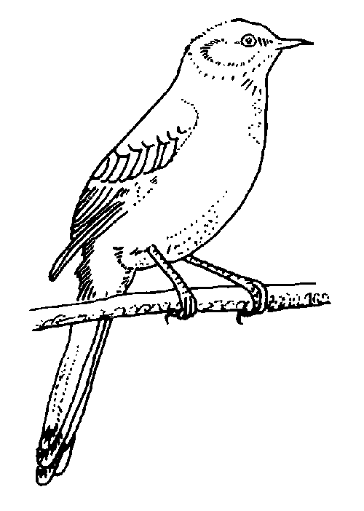
Chapter 12  Scout, Jem, Calpurnia | Respect/ Courage | - At first Jem and Scout felt out of place at Cal’s church because they were white but then realized that most members were accepting and respected Atticus.
Characters | Law of Life | Example from Novel | Visual
13

14

15

Characters | Law of Life | Example from Novel | Visual
16

17

18

19

Characters | Law of Life | Example from Novel | Visual
20

21

22

Characters | Law of Life | Example from Novel | Visual
23

24

25

26

Characters | Law of Life | Example | Visual
27

28

29

30

